ROBOMANIPAL
(Edge AI)

ARDUINO
Arduino Uno is a microcontroller board. It has 14 digital input/output pins (of which 6 can be used as PWM outputs), 6 analog inputs, a 16 MHz ceramic resonator(clock speed), a USB connection, a power jack, an ICSP header and a reset button. It contains everything needed to support the microcontroller. It can be connected to AC/DC battery
Ideal for:
DIY electronics, sensor-based projects, small robots, and automation systems
Specifications-
Operating voltage-5v
Input voltage-6-20v
Digital I/O ins-14 pins
PWM pins-6
Analog pins-6
DC current input-20 mA
DC current for 3.3v pin-50 mA
Flash memory-32 KB
RAM-2KB
Microcontroller-ATmega328P
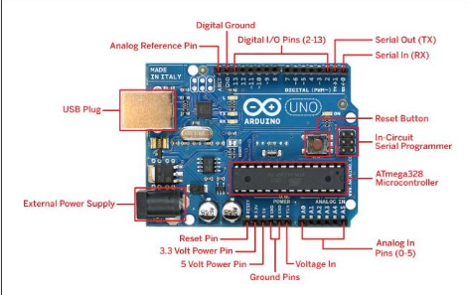

RASPBERRY PI
- It is a single board computers(SBC)which offers high-performance hardware, full Linux operating system. and a variety of common ports in a form factor roughly the size of a credit card.
Ideal for:
IoT servers, home automation, coding education, and AI-based projects

Specifications-
Operating Voltage – 5V
Input Voltage – 5V DC via USB-C or GPIO header
Processor – Broadcom BCM2711 quad-core ARM Cortex-A72 (64-bit) clocked at 1.8 GHz
Memory (RAM) – 1 GB / 2 GB / 4 GB / 8 GB LPDDR4-3200 SDRAM
Digital I/O Pins – 40-pin GPIO header
PWM Outputs – 2 hardware PWM channels (supports software PWM)
Analog Inputs – Not available (external ADC required)
Wireless Connectivity – Dual-band Wi-Fi (2.4 GHz & 5 GHz, 802.11ac), Bluetooth 5.0, BLE
Display Interface – MIPI DSI
Camera Interface – MIPI CSI
Graphics Support – OpenGL ES 3.1, Vulkan 1.0
Storage Medium – Micro-SD card
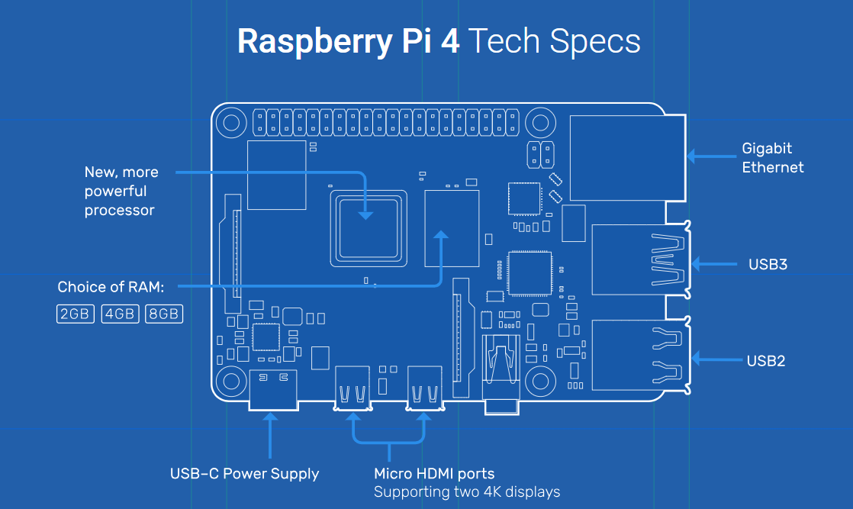

ESP32 DEV BOARD
The ESP32-S3 is a Wi-Fi and Bluetooth-enabled microcontroller optimized for IoT and edge AI applications. It supports low power consumption, multiple interfaces, and has AI acceleration capabilities for lightweight ML models. It’s widely used in wireless and smart device systems that require energy efficiency.
Ideal for:
IoT devices, wireless sensors, smart home automation, and edge AI systems.
Specifications-
Operating voltage – 3.3V
Input voltage – 5V via USB / VIN pin
Microcontroller – ESP32-S3 Xtensa LX7 dual-core (up to 240 MHz)
RAM – 512 KB SRAM (plus optional external PSRAM up to 8 MB)
Flash memory – 4 MB / 8 MB / 16 MB (module dependent)
Digital I/O pins – 45 GPIO pins
PWM pins – Up to 8 PWM channels
Analog pins – 20 ADC channels (12-bit)
Wireless connectivity – 2.4 GHz Wi-Fi (802.11 b/g/n), Bluetooth 5.0 LE
AI acceleration – Vector instructions for AI/ML
Programming support – Arduino IDE, ESP-IDF

NVIDIA JETSON
The Jetson Nano is a compact, yet powerful AI development board designed for machine learning, computer vision, and robotics. It features an ARM Cortex-A57 CPU with an NVIDIA GPU that supports frameworks like TensorFlow, PyTorch, and OpenCV. It’s commonly used for AI-powered robotics, object detection, and autonomous systems.
Ideal for:
AI-based robotics, edge computing, and image recognition
Specifications-
Operating voltage – 5V
Input voltage – 5V DC (micro-USB / DC barrel jack)
Processor – Quad-core ARM Cortex-A57 (64-bit) @ 1.43 GHz
GPU – 128-core NVIDIA Maxwell GPU
RAM – 4 GB LPDDR4
Digital I/O pins – 40-pin GPIO header
Wireless connectivity – External Wi-Fi / Bluetooth via USB or M.2 module
AI performance – Up to 472 GFLOPS
Storage – Micro-SD card
Operating system – Linux (JetPack SDK, Ubuntu-based)

DIFFERENCES
RASPBERRY VS ARDUINO
Feature | Arduino | Raspberry Pi
Type | Microcontroller board | Microprocessor-based single board computer
Operating system | No OS | Linux OS
Boot time | Instant | 20–40 seconds
Programming languages | C / C++ | Python, C, C++, Java
Processing power | Low | High
RAM | Very limited (KBs) | High (GBs)
Storage | Flash memory | SD card
Real-time control | Yes | Not real-time (by default)
Analog input | Built-in ADC | Requires external ADC
GPIO response | Deterministic | Non-deterministic
Power consumption | Very low | High
Connectivity | Limited (needs modules) | Ethernet, Wi-Fi, Bluetooth
Display support | Limited | HDMI, display interfaces
Cost | Low | Higher
Typical use cases | Sensors, motors, control systems | AI, computer vision, servers

